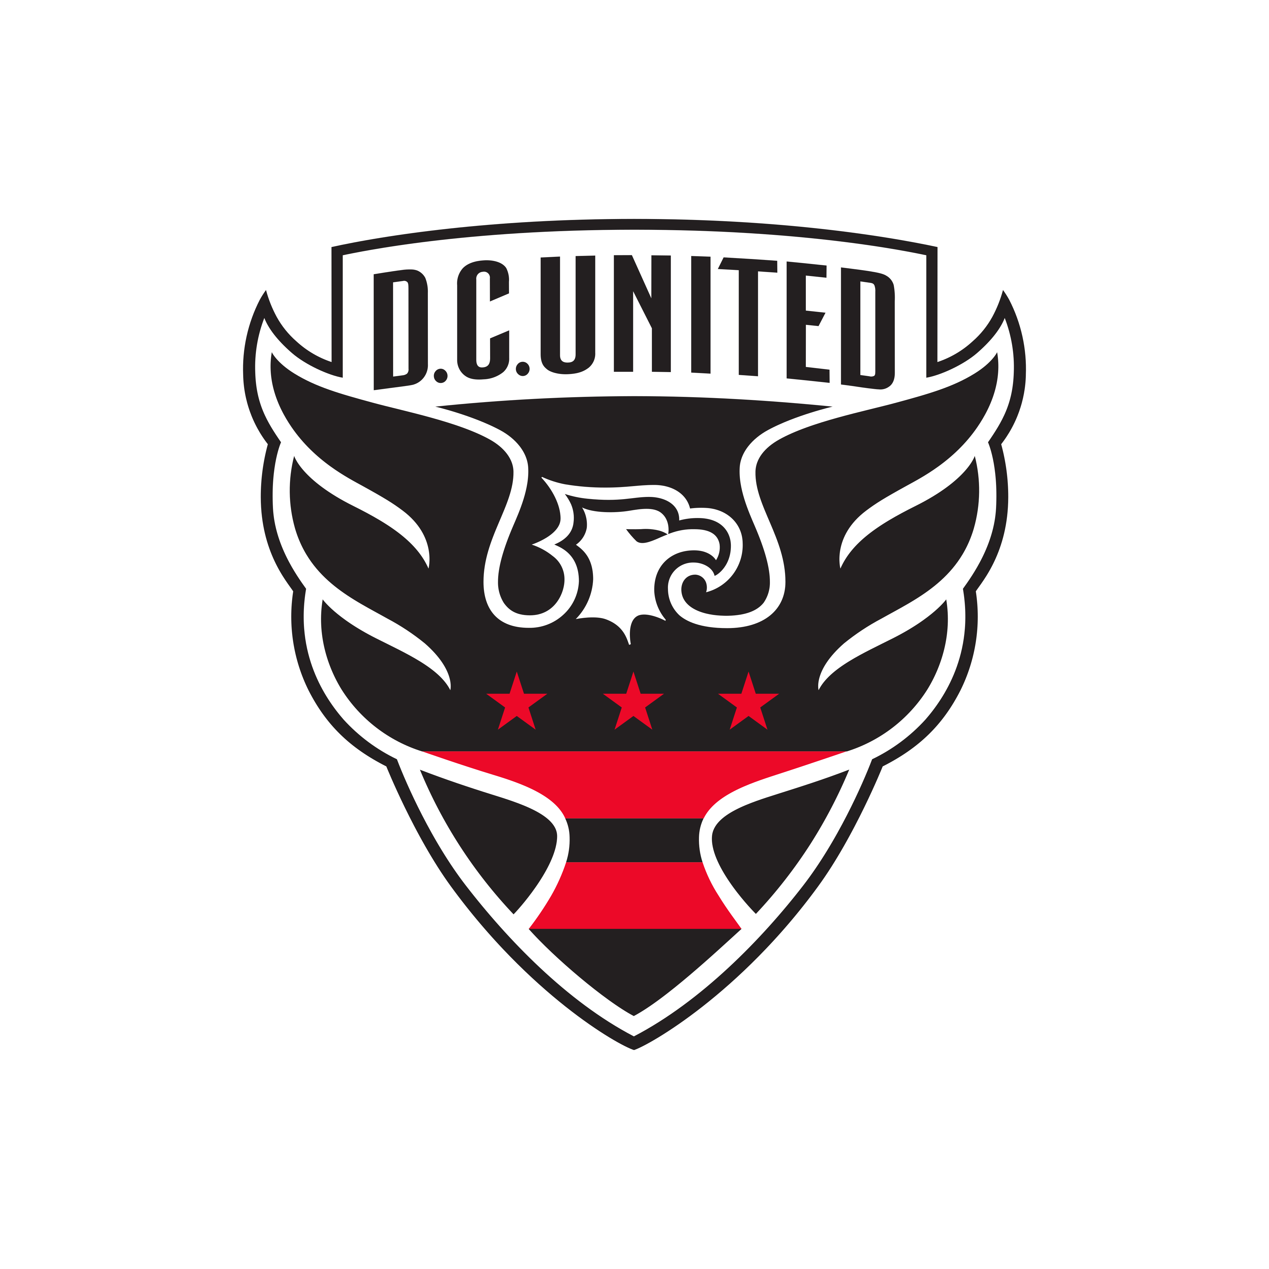
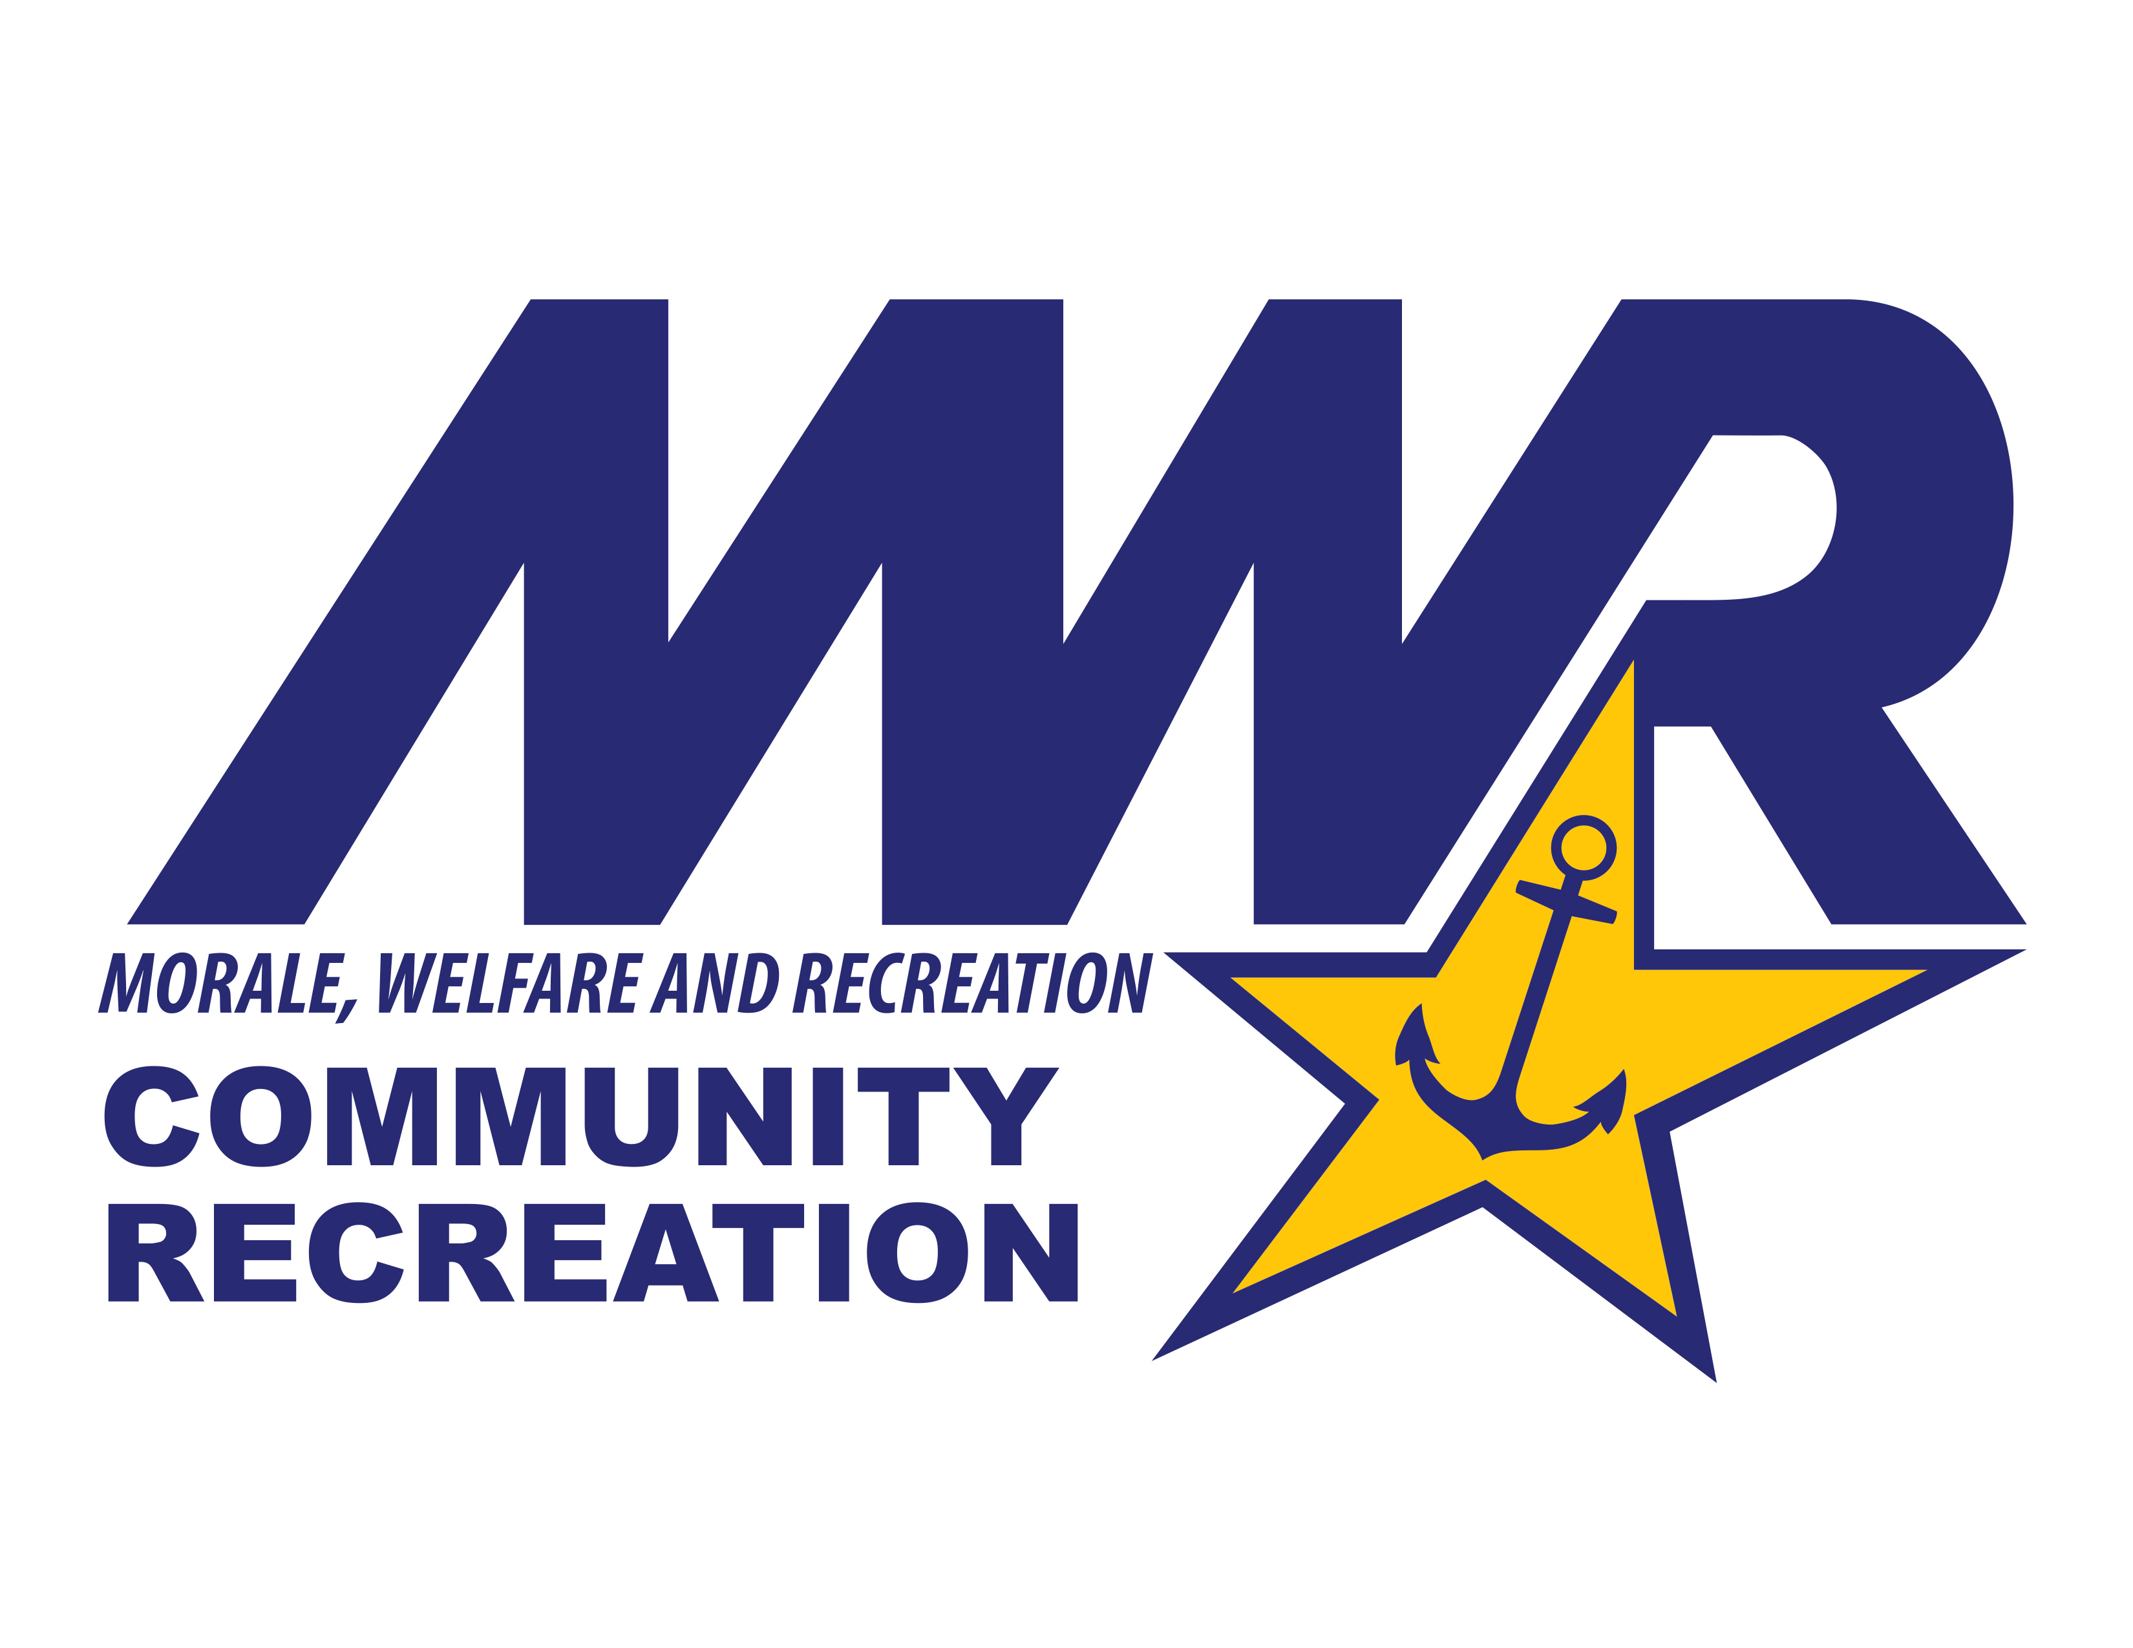
DC United 2026
Opponent | West Sideline (Sec. 201-203 & 208-210) | Middle Endline (Sec. 115-119) | Club (Section C1)* | Ticket Type | # of Tickets
Chicago 5/13 | $51.75 | $40.75 | $229.00
St. Louis 5/16 | $55.00 | $44.00 | $229.00
Montreal 5/23 | $51.75 | $40.75 | $264.00
Toronto 7/25 | $55.00 | $44.00 | $229.00
Nashville 8/1 | $51.75 | $40.75 | $264.00
New England 8/19 | $51.75 | $40.75 | $264.00
LAFC 8/29 | $55.00 | $44.00 | $264.00
Columbus 9/9 | $51.75 | $40.75 | $229.00
Atlanta 9/12 | $55.00 | $44.00 | $264.00
Charlotte 9/19 | $55.00 | $44.00 | $264.00
New York 10/14 | $51.75 | $40.75 | $264.00
Cincinnati 10/24 | $55.00 | $44.00 | $264.00
New York City 11/7 | $55.00 | $44.00 | $264.00
 |  |  |  | Total:
*The Club Level is all inclusive of Food and Beverage/Alcohol, provides access to the indoor club lounge, and provides padded seating next to the player benches.
Customer Name:_______________________________________________________
Personal Email:________________________________________________________
Phone Number:________________________________________________________
Tickets Ordered Date:_______________________
Tickets Ordered Received:____________________
Tickets are prepaid and ordered based on availability. Tickets will be sent to your email address. Please download the Ticketmaster App on your smartphone or computer to download and receive your tickets.

