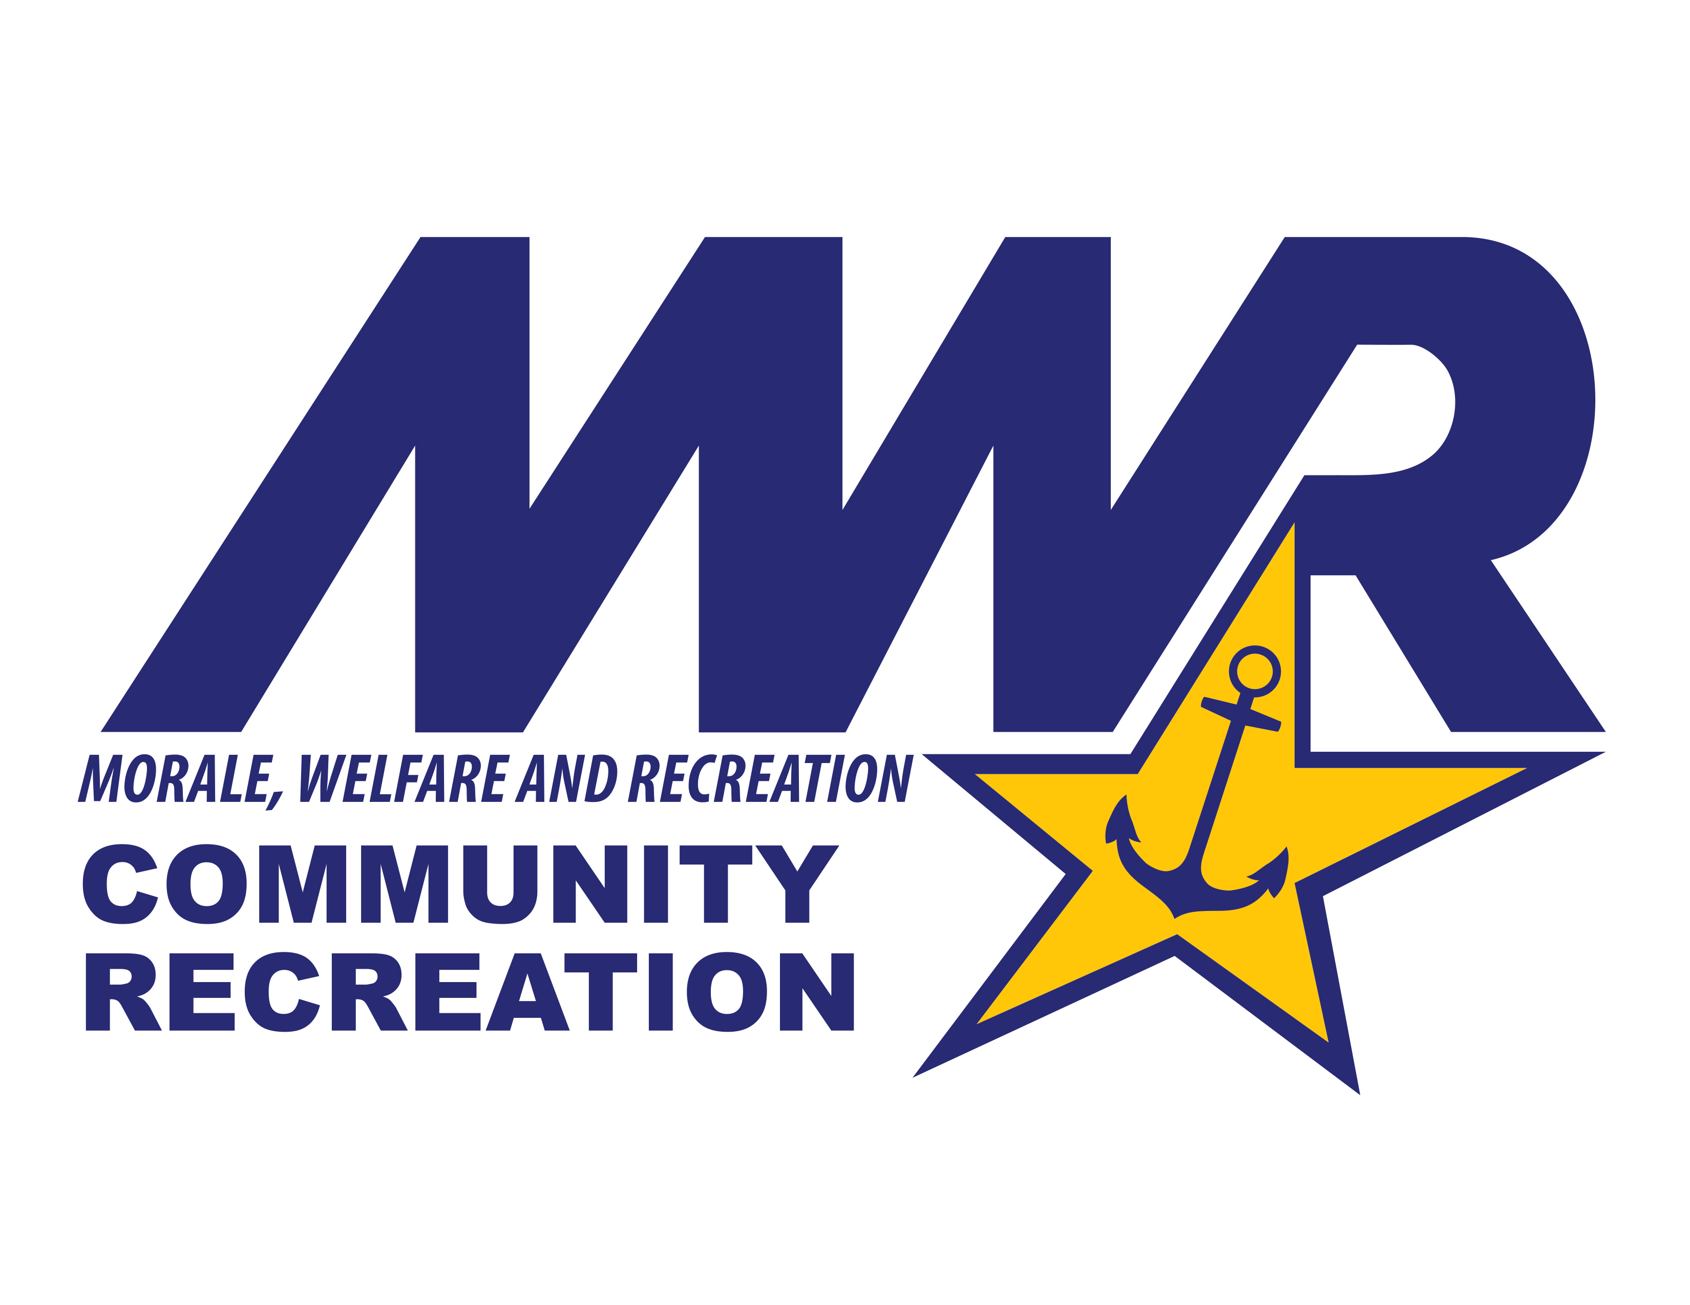
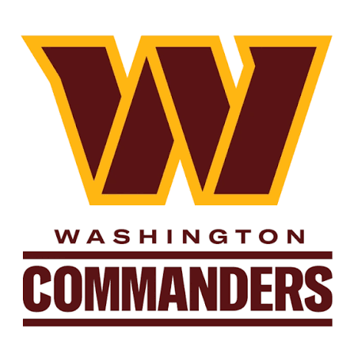
Washington Commanders
Customer Name: _______________________________________________________
Personal Email: ________________________________________________________
Phone: _______________________________________________________________
Tickets must be ordered seven business days before game date. SEATGEEK App needed.
Texans (12/13) Falcons (12/20) Bengals (11/23) | MWR Price | # Tickets | Total
Club Level Sideline (302-303, 319-320, 323-324, 340-341) | $423.50
Club Level Endzone (307-309, 313-315, 328-330, 334-336) | $302.50
Lower-Level 200 Sideline (218-225) | $214.50
Lower-Level End Zone (118-119, 124-125) | $197.00
Upper-Level Sideline (401-404, 424-431, 451-454) | $120.00
Upper-Level Corner (405-409, 419-423, 432-436, 446-450) | $76.00
Seahawks (9/27) Rams (11/8) | MWR Price | # Tickets | Total
Club Level Sideline (302-303, 319-320, 323-324, 340-341) | $434.50
Club Level Corner (307-309, 313-315, 328-330, 334-336)  RAMS GAME ONLY | $384.00
Club Level Endzone (307-309, 313-315, 328-330, 334-336)  SEAHAWKS GAME ONLY | $346.50
Lower-Level 200 Sideline (218-225) | 236.50
Lower-Level End Zone (106-116, 127-137, 206-216, 227-237) | 219.00
Upper-Level Sideline (401-404, 424-431, 451-454) | 131.00
Upper-Level Corner (405-409, 419-423, 432-436, 446-450) | $82.50
Giants (10/11) | MWR Price | # Tickets | Total
Club Level Sideline (302-303, 319-320, 323-324, 340-341) | $434.50
Club Level End Zone (304-306, 316-318, 325-327, 337-339) | $346.50
Lower-Level 200 Sideline (218-225) | $247.50
Lower-Level End Zone (106-116, 127-137, 206-216, 227-237) | $230.00
Upper-Level Sideline (401-404, 424-431, 451-454) | $137.50
Upper-Level Corner (405-409, 419-423, 432-436, 446-450) | $87.00
Cowboys (TBD) Eagles (11/1) | MWR Price | # Tickets | Total
Club Level Sideline (302-303, 319-320, 323-324, 340-341) | $522.50
Club Level Corner (307-309, 313-315, 328-330, 334-336)  COWBOYS GAME ONLY | $456.50
Club Level End Zone (304-306, 316-318, 325-327, 337-339)  EAGLES GAME ONLY | $417.00
Lower-Level 200 Sideline (218-225) | $340.00
Lower-Level End Zone (106-116, 127-137, 206-216, 227-237) | $302.50
Upper-Level Sideline (401-404, 424-431, 451-454) | $181.50
Upper-Level Corner (405-409, 419-423, 432-436, 446-450) | $115.50
Parking | MWR Price | # Tickets | Total
Regular Season | $82.50

