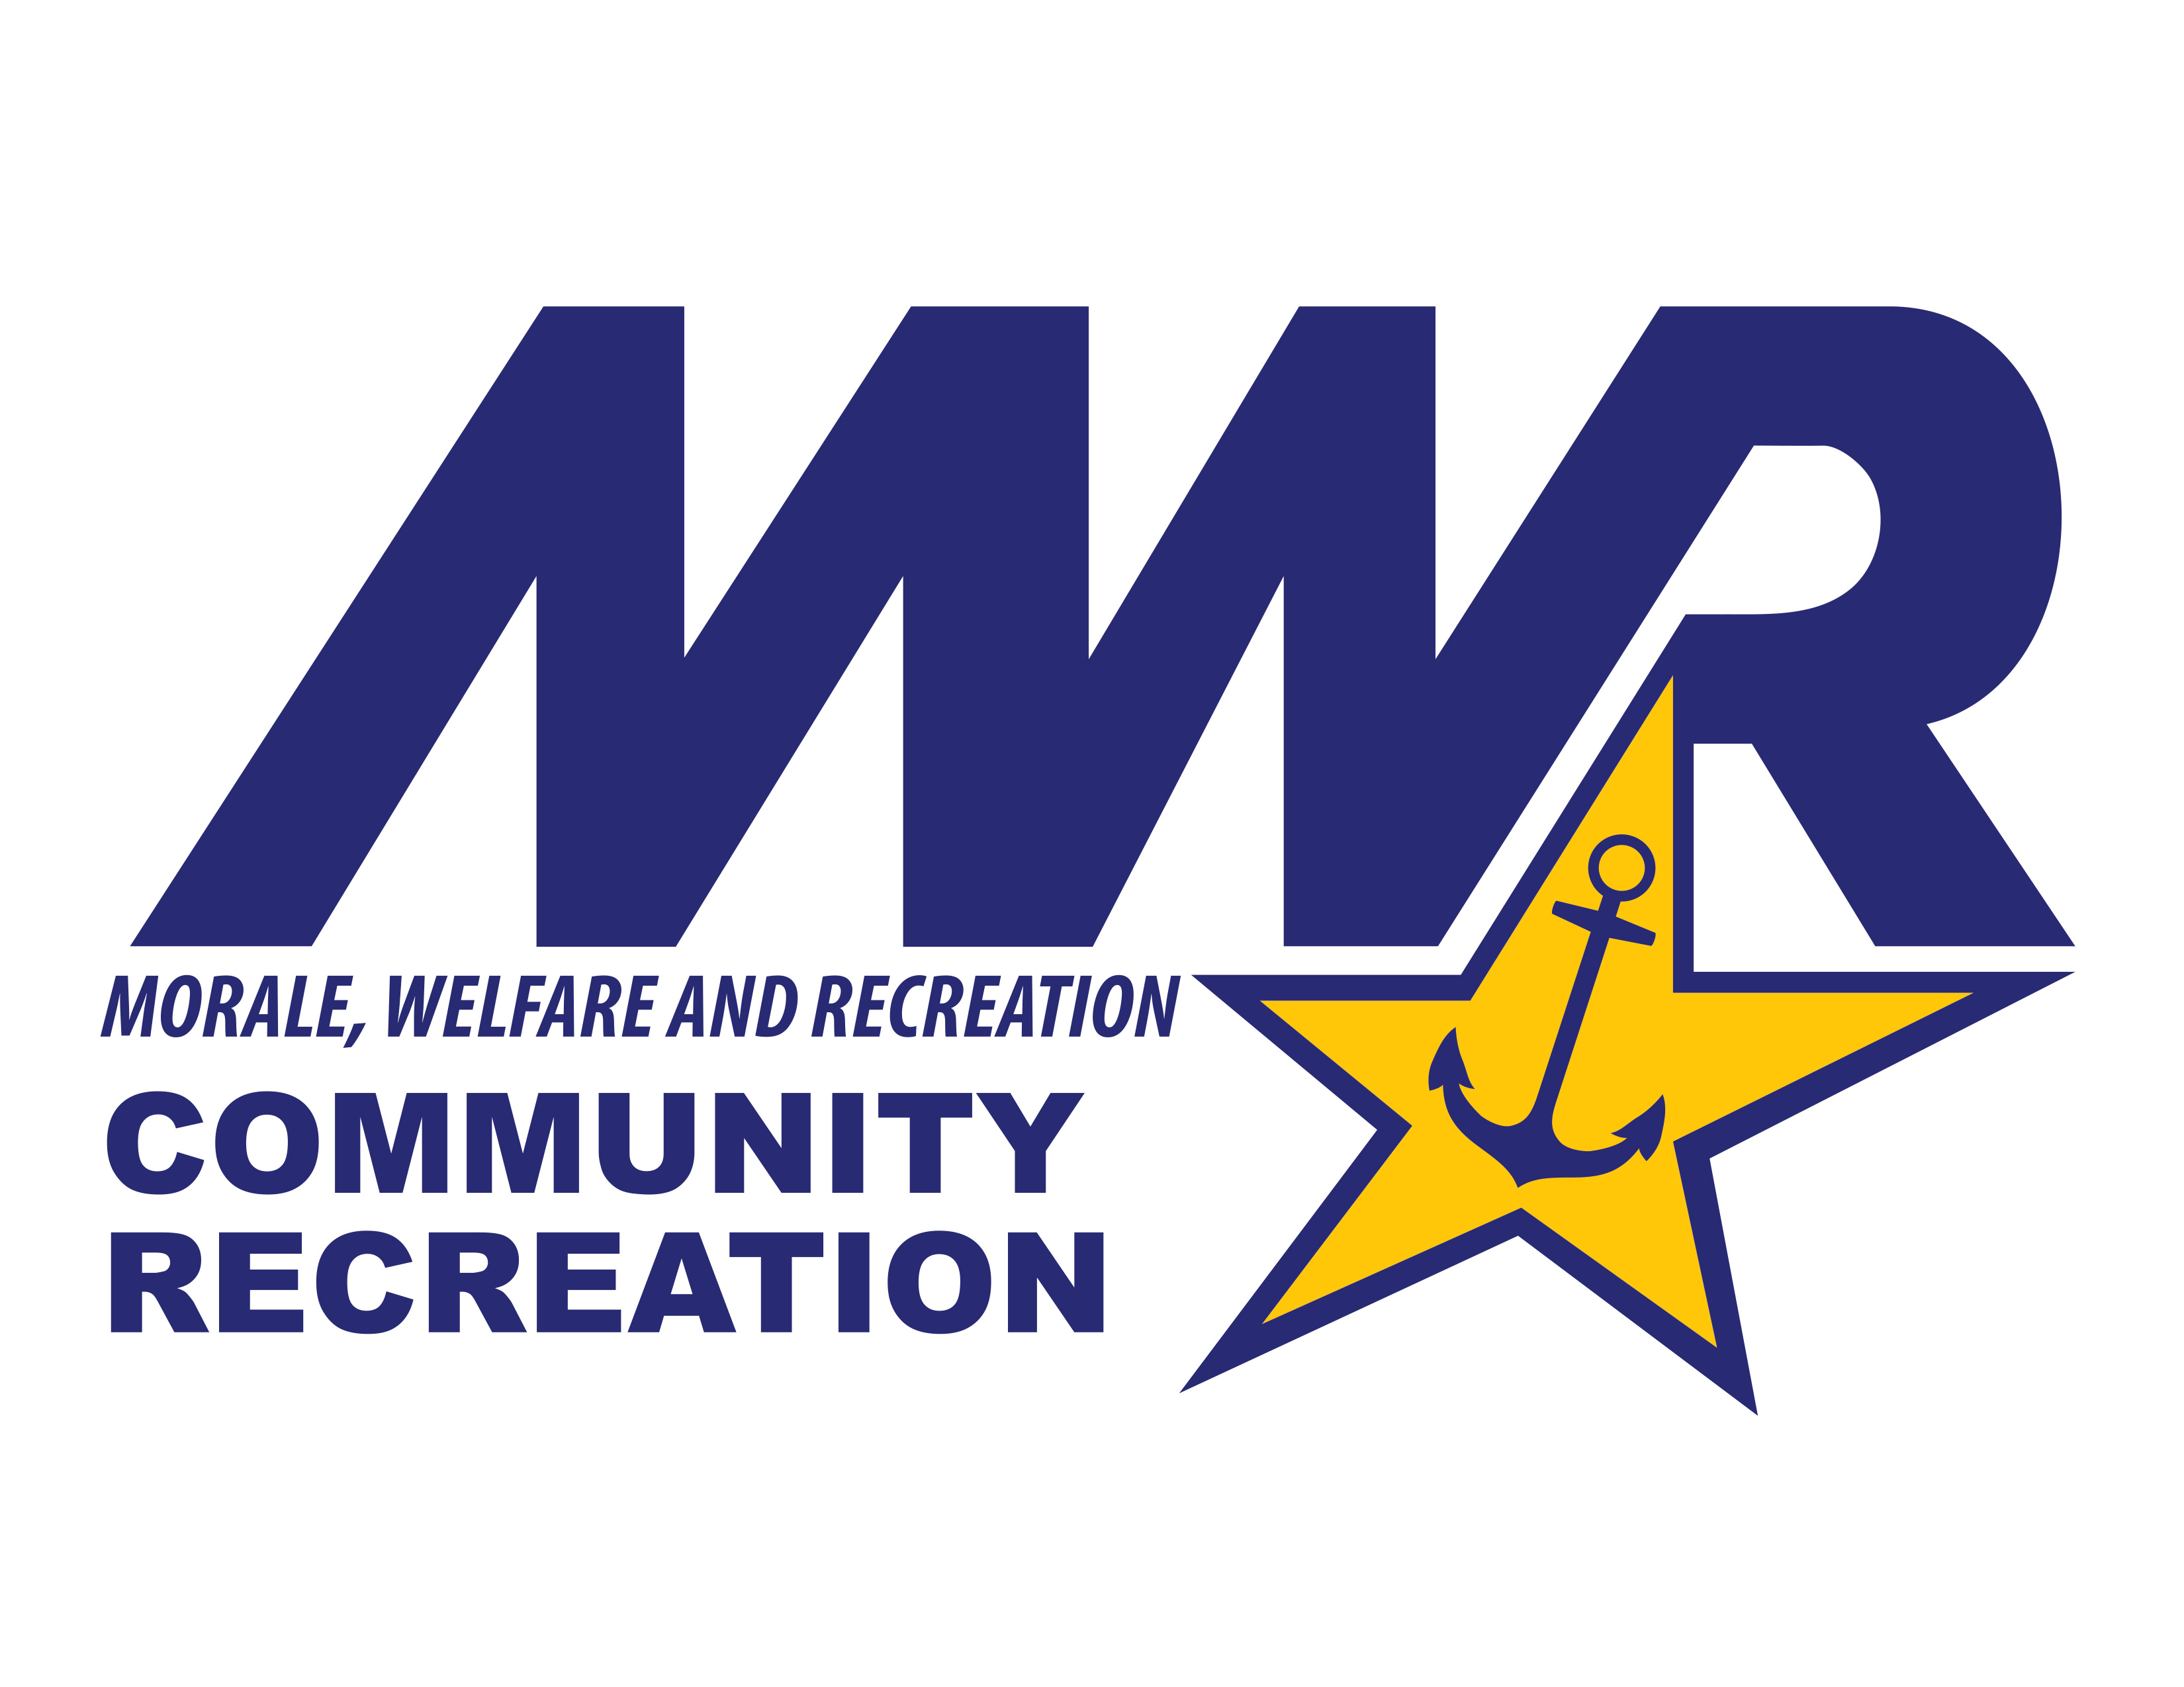
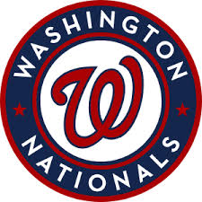
Washington Nationals 2026

Customers Name:_____________________________________
Personal Email:_______________________________________
Phone Number: _______________________________________
Seating: | MWR Price | Price Includes F&B Voucher worth: | Game Date | Qty.
PNC Diamond Club  Sec. 119-126 | $242.00 | All Inclusive
Dugout Box  Sec. 114-120, 127-131 | $131.00 | $25.00
Infield Box  Sec. 114-120, 126-131 | $103.50 | $20.00
LF/RF Baseline Reserved  Sec. 111-113, 132-134 | $78.25 | $15.00
LF/RF Corner  Sec. 108-110, 135-137 | $65.00 | $10.00
RF Mezzanine  Sec. 223-235 | $56.25 | $10.00
Upper Gallery  Sec. 403-409, 416-420 | $26.50 | N/A

