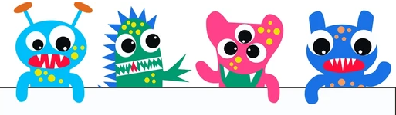
Contest Entry Form

Halloween Door Decorating Contest

📽️ Theme: Your Favorite Monsters or Ghouls. Get creative and turn your door into a masterpiece!
Who Can Enter: Office Group Entry.

Office/Group Entry
Name/ Office Name:_______________________/_________________________
Email:____________________________________________________________
Phone:___________________________________________________________

Contest Rules:
How to Enter: Snap 2 photos of your decorated door (In good lighting, please)
Email entry form & photos to: NSAW-cr-tickets@us.navy.mil
Deadline: Submit by Friday, October 23, 2025
Theme: Favorite Monster or Ghouls
Deadline: All doors must be submitted for judging by 5pm on 23Oct26
Safety First: No open flames, hazardous materials, or items that obstruct walkways.
Respectful Content: Designs must be appropriate for all audiences—no offensive or controversial imagery.
Judging: Winner will be announced on Thursday Oct 29th at the Fright Night at Mordechai’s Booth at 5:30pm
If not in attendance, winner will be emailed Friday 30Oct26 at 8AM.
Judged on creativity, theme adherence, and overall presentation.
Prize: The winning office will enjoy a catered lunch, valued at up to $150
